

**REPORT ON:**

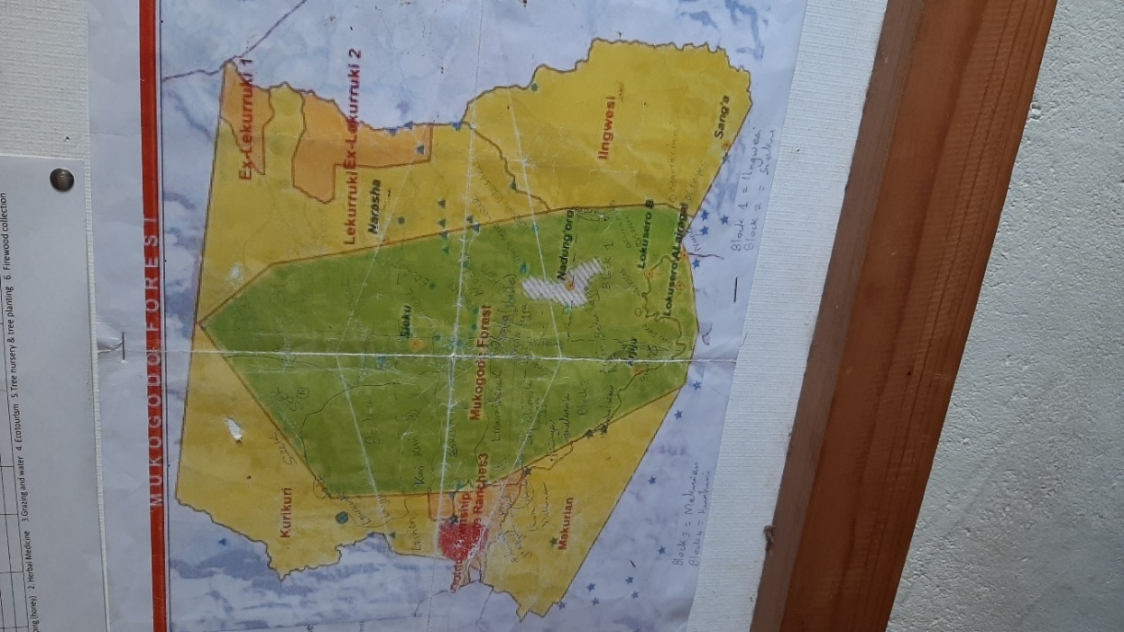**ILMAMUSI CFA AND KEFRI NYERI SCIENTISTS MEETING TO DELIBERATE ON NURSERY ESTABLISHMENT AND MANAGEMENT AT ILMAMUSI CFA OFFICE AND LOKUSERO SECONDARY SCHOOL.**

**Compiled by: Stephen M Ndung’u, Evans Cheruiyot, Elisa Moraa and Sheila Kimoning.**

**Date: 15/03/2024**

1. **Introduction**

Ilmamusi Mukogodo Forest Association is a registered community forest association responssible for management of Mukogodo forest reserve under a Management agreement with the Kenya Forest Service (KFS). Mukogodo forest is the largest forest in Laikipia County covering a vast 30,189 hectares of natural forest. The forest is a national water tower and is one among a dozen remaining indigenous forests of importance in Kenya.

The trip to Mukogodo was more of an affirmation of the power of collective community effort. A semi- arid forest, filled with numerous indigenous species, located at a higher point out from the highway and into the rough road with the Mt. Kenya peaks as the backdrop filled with spectacular geographic scenes, wildlife, equal measure of scorching heat and cooling breeze is located in Laikipia County.

As a community forest it is managed and operated by Ilmamusi Community Forest Association. As one of their strategic plans, the group through their board members are seeking to establish two tree nurseries. One located next to their office and at the Lokusero Secondary School further downhill. As with group or community nurseries, the establishment often requires external support from NGOs or government agencies. This support includes a range of resources and with this particular field excursion, the Ilmamusi CFA required technical know- how in form of training on the establishment and management of tree nurseries from KEFRI.

1. **Objectives**
2. To meet the Ilmamusi CFA board member representatives and discuss on how to establish and manage a tree nursery.
3. To carry out a reconnaissance on the proposed sites for tree nurseries establishment and advice accordingly.
4. **Site visit and selection**

KEFRI team upon request by the Ilmamusi board members visited the sites on 12th March 2024.

1. **Site A: Next to Ilmamusi offices**

The team visited the suggested location next to Ilmamusi offices and confirmed to be a suitable site to establish a tree nursery. It is accessible and will be supplied with water soon the proposed water connection is done. It has access to good soil due to its proximity to the community forest itself. It is slightly sloping with good drainage. It has exposure to sunlight and is secure from animals and human because of the strong social fence and it being the highest point in the area.

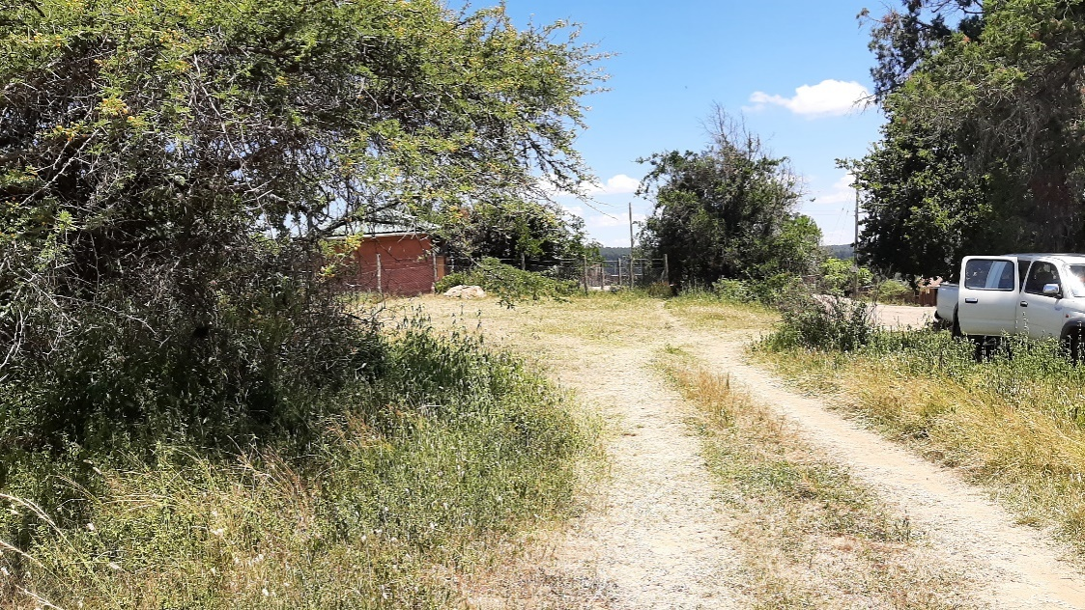

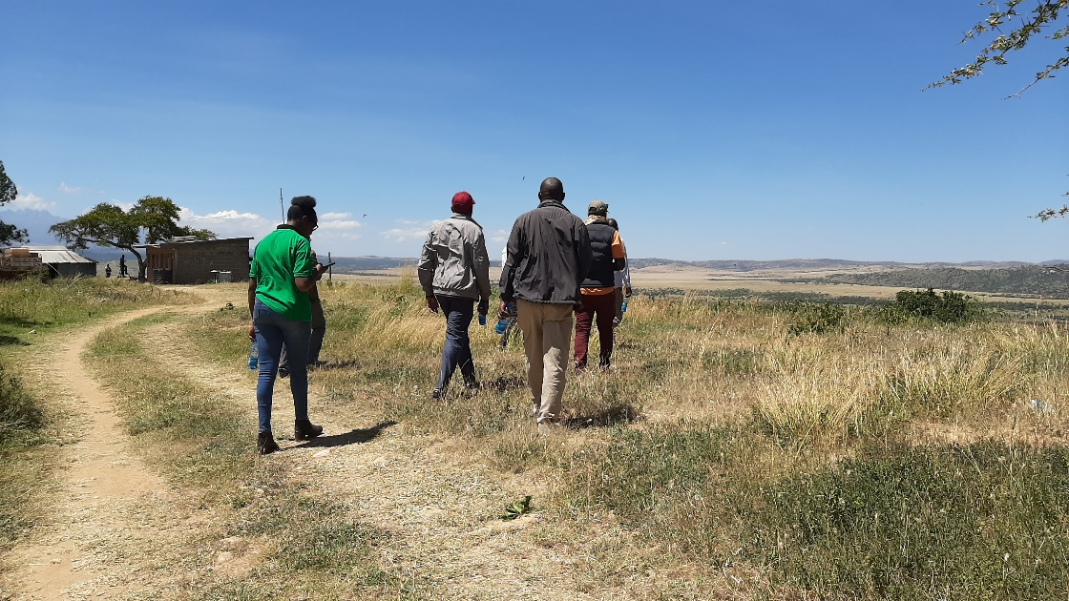

Figure 2 and 3: The proposed tree nursery site next to the Ilmaamusi Offices

1. **Site B: Lokusero Secondary School**

The team visited another site at Lokusero secondary School. The site is ideal with already installed infrastructure such as seedbeds, water tank stand and a functional shade net. The site

is fenced with barbed wire and chain-link and is situated inside the school compound.

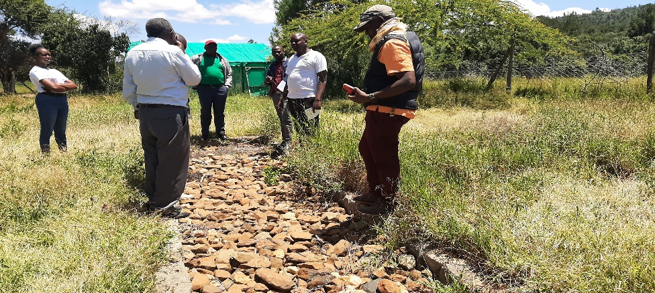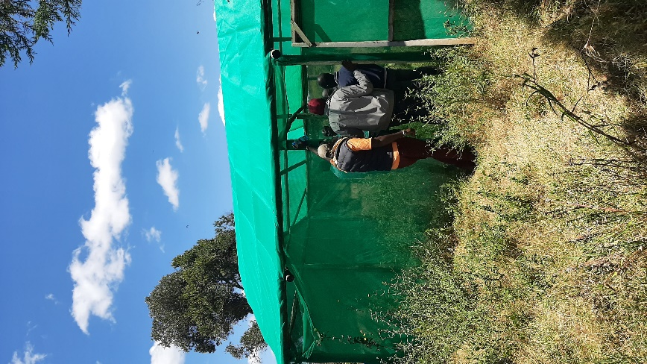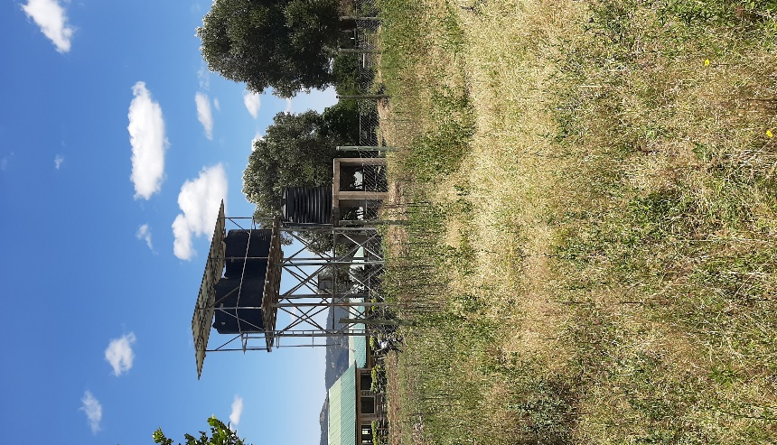

Figure 4,5,6: Lokusero Mixed Secondary School

1. **Discussion**

To develop technical skills required in the establishment and management of nurseries, the Ilmamusi board members suggested a field visit day at KEFRI Nyeri so as to familiarise themselves with a nursery set up and management.

The CFA was advised on the importance of aligning their strategy with the 15 billion tree planting program initiated by the current government. This is because nurseries support reforestation and tree programmes. It was stated that a nursery allows growth in phases. It gives groups room to start with what they have, measure their strength and build on it as time goes by. This eases their activities and once they are known and established it makes it easier for other groups in the market to work with them.

To meet communal and commercial needs, viewing the nursery as an enterprise was highly adviced. They were encouraged to explore the idea of seedlings sales from already existing indigenous trees such as the *Juniperus procera*, *Olea Africana* among many others. A suggestion too on the introduction of Melia was made. The proposed alternative was using of exotic tree seedlings though cautiously to avoid creating a menace from Invasive species. Also, the were advised to consider fruit trees as a component.

The CFA mentioned that together with it being an income generating project, they would also like to enhance the technical capacity by serving as an important training ground for the community. As the chairman stated, it all comes down to ‘starting with the right footing; to set a good example for others’

1. **Recommendation**
2. **Site selection**

The CFA needs to determine the type of nursery they intend to create next to their office. This will in turn determine if their seed beds will be temporal or permanent. The KEFRI team suggested the creation of a tank stand and shade. Also, they were advised to consider pruning one of the existing trees to provide shade in the nursery. Other than the pre-existing social fencing, a physical fence was recommended.

At Lokusero Secondary school, the two present seedbeds need fixing to make the nursery operational.

KEFRI technical person will help in actual actions like seedbeds preparation, seed sowing etc.

1. **Staff training**

To develop technical skills required in the establishment and management of nurseries, the members suggested a field day at KEFRI Nyeri.

They were encouraged to balance the involvement of man and machine to make the project successful and encourage collective ownership of the nursery.

To avoid the availability of labour constraints in the management of the nurseries, they were advised to carry out their projects in phases and gradually grow.

1. **Seed availability**

Tree seeds are always provided by KEFRI countrywide. However, the groups will be taught on seed handling techniques to help them harvest mature tree seeds from the Mukogodo forest. For seed propagation, methods such as layering for some trees was suggested to reduce the over dependence on purchasing seeds.

1. **Tree nursery requirements**

Some of the requirements for setting up a new tree nursery have been provided in the attached Annex 1 below.

1. **Conclusion**

A number of factors need to be considered in the establishment and management of a tree nursery other than the ones mentioned in this report. Factors such as the importance of communication in collaborative projects, community engagement in all phases of establishment and management and innovation are hardly mentioned but are equally important as determined from this field visit.

KEFRI team is ready and promises to work closely with the proposed tree nurseries, when called upon, to ensure its success and sustainability.

**ANNEX 1.**

**REQUIREMENTS FOR ESTABLISHMENT OF A NEW TREE NURSERY AND TENTATIVE BUDGET FOR 50,000 SEEDLINGS.**

N/B the number of items and the prices are adjustable depending on nursery size and market prices respectively.

|  |  |  |  |  |
| --- | --- | --- | --- | --- |
|  | **Requirements: adjustable depending on the intended capacity of the nursery** | | | |
|  | **Items** | **Unit cost(Kshs)** | **Quantity** | **Total (Kshs)** |
|  | Spade | 700 | 2 | 1400 |
|  | Wheelbarrow | 5000 | 2 | 10000 |
|  | Bucket(water) | 200 | 2 | 400 |
|  | Watering can | 500 | 2 | 1000 |
|  | Rake | 400 | 2 | 800 |
|  | Fork jembe | 1000 | 2 | 2000 |
|  | Panga | 700 | 2 | 1400 |
|  | Jembe | 800 | 4 | 3200 |
|  | Hose Pipe ¾ (36m) | 4000 | 2 | 8000 |
|  | Sun Shade net 80% | 4000 | 5pcs | 20000 |
|  | Chain link(18M)-Fence | 3000 | 8 | 24000 |
|  | Laying of water tank |  |  | 20,000 |
|  | Water tank (10,000L) |  |  | 85,000 |
|  | PVC pipes and its accessories |  |  | 10000 |
|  | Potting materials  4X6  5x8  8x10 | 120/pkt  150/pkt  180/pkt | 100pkts  200pkts  50pkts | 12000  30000  9000 |
|  | Punning knife (For root pruning) | 250 | 4 pcs | 1000 |
|  | Surgical blade | 2000 | 1 pkt | 2000 |
|  | Assorted Rooting media | 3000 |  | 3000 |
|  | Para film paper for grafting | 2000 |  | 2000 |
|  | Compost manure  Forest/garden soil |  | 5tons  15tons | 20,000 |
|  | Others: Linear tape/string, off sawn timber,nails etc.(for laying of temporary timber seedbeds) |  |  | 50,000 |
|  | Fencing poles | 500 | 200 | 10,000 |
|  | Chain link | 10,000 | 5 | 50000 |
|  | Sand (5 tones) |  |  | 30,000 |
|  | Barbed wire | 5000 | 2 | 10,000 |
|  | Green house construction |  |  | 400,000 |
|  | Shade house construction materials |  |  | 50,000 |
|  | Assorted chemicals: Fungicides, foliar feeds |  |  | 10,000 |
|  | **Assorted indigenous tree seeds from KEFRI(Some seeds might not be available)** | | | |
|  | **Seeds** | **Unit cost(Kshs/kg)** | **Quantity(kg)** | **Total(Kshs)** |
|  | *Markhamia lutea* | 2000 | ½ | 1000 |
|  | *Cordia africana* | 2000 | 2 | 4000 |
|  | *Croton megalocarpus* | 2000 | 2 | 4000 |
|  | *Teclea nobilis* | 3000 | 1 | 3000 |
|  | *Juniperus procera* | 2000 | 2 | 4000 |
|  | *Podocarpus falcatus* | 1500 | 3 | 4500 |
|  | *Olea africana* | 3000 | 1 | 3000 |
|  | *Prunus africana* |  |  |  |
|  | *Spathodea companulata* | 3500 | ½ | 1750 |
|  | *Schinus molle* | 1500 | 1 | 1500 |
|  | *Senna spectabilis* | 1500 | 1 | 1500 |
|  |  |  |  |  |
|  |  |  |  |  |