

**REPORT ON TREE PLANTING DAY AT NGAANI PRIMARY SCHOOL**

**DATE: 25TH NOVEMBER 2024**

**LOCATION: NGAANI PRIMARY SCHOOL, MUTHA LOCATION, NGAANI SUB-LOCATION**

**ORGANIZED BY: WELT HUNGER HILFE**

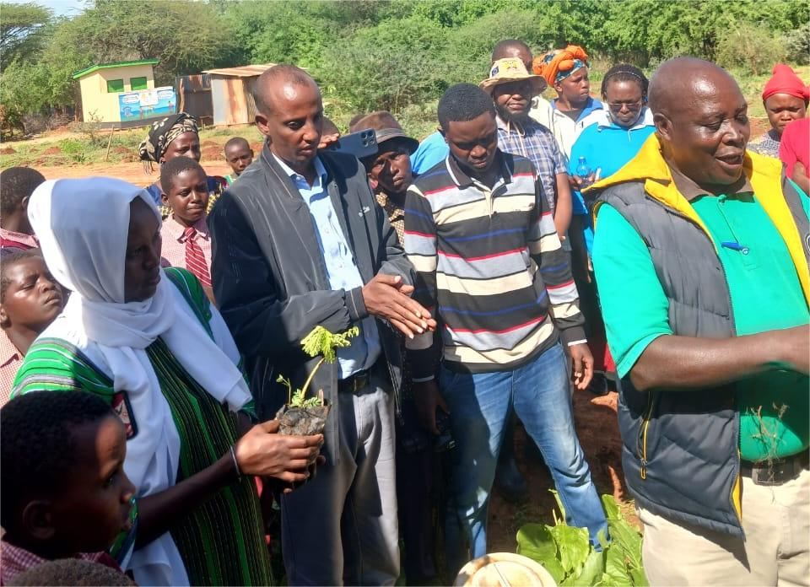

**Introduction**

The tree plant event at ngaani primary school was organised as part of broader initiative to promote environmental conservation and address critical challenges such as deforestation and water scarcity.the event brought together various stakeholders including representatives from county government of kitui, kenya forest research institute[kefri], kenya forest service[kfs], welt hunger hilfe[whh]. water resources authority[WRA], local administration, parents and pupils.The occasion aimed to foster awareness about the importance tree planting and to empower the local community to take action towards sustainable environmental practices.

**Opening Remarks**

The event commenced with the head teacher of ngaani primary school welcoming all stakeholders,parents and pupils.he expressed his gratitude to welt hunger hilfe for organising the event and for their generous donation seedlings. A parent was appointed to lead the gathering in a word of prayer, setting atone of unity and purpose.

The master of ceremonies then facilitated the introduction of the stakeholders present, allowing each representative to share their role and contribution to the initiative.

**speech**

A representative from the County Government's Department of Health, specifically the Public Health Officer, emphasized the connection between water-related diseases and environmental degradation. He advocated for tree plantation as a critical step toward mitigating these challenges and highlighted its alignment with the Sustainable Development Goals (SDGs). He further stressed the importance of community-driven efforts to ensure the sustainability of the trees being planted at Ngani Primary School.

Puis Matheka, a representative from the Kenya Forestry Research Institute (KEFRI), outlined KEFRI's role in promoting tree planting technologies and sustainable management of natural resources. He mentioned that KEFRI offers free training to community members to enhance their capacity in tree planting and allied activities.

The Assistant Chief of Ngaani Sub-location shared details about the national tree-planting directive, which sets a target of planting 260 trees per location each month. He urged community members to report any trees planted to their area chiefs to ensure proper tracking and accountability

Ward Administrator Ezekiel Wambua emphasized that tree planting is a directive from the President of Kenya, making it a legal requirement for all citizens. He urged everyone to adhere to this government mandate as part of their civic responsibility.

Mr. Chirchir, a representative from Mtopo Forest Station under the Kenya Forest Service (KFS), highlighted the critical role of trees in environmental conservation. He advocated for tree planting in all educational and public institutions as a means to foster a culture of sustainability and environmental stewardship.

A representative from the Water Resources department underscored that trees are invaluable gifts to the planet, serving as a foundation for life. She emphasized the direct connection between trees and water availability, stating, "No trees, no water," to stress the importance of afforestation for water conservation and ecosystem balance.

**Activities**

Trees were planted within the school compound, with each pupil assigned a tree to care for.

Guests and community members participated in the tree planting activity, demonstrating the collective responsibility for environmental conservation.

**Conclusion**

The tree planting day at Ngani Primary School was a success, fostering awareness of the importance of trees and mobilizing the community to take action for environmental conservation. The pupils, as future custodians of the environment, were inspired to take an active role in tree growing and sustainable practices.

**Objectives**

To emphasize the importance of tree planting as a strategy for environmental conservation and community empowerment

To provide a detailed account of the roles and messages delivered by various stakeholders during the event, promoting the shared responsibility of tree growing and care.

To create awareness about the ecological, social, and economic benefits of trees, as discussed during the event.

To encourage the community, school management, and pupils to adopt sustainable practices, such as tree protection, proper watering, and achieving high survival rates of planted trees

**Methodology**

**Stakeholder engagement**

Key stakeholders , including public officials, environmental experts,, School representatives, parents and pupils were invited to participate. Speeches by various representatives emphasized the importance of tree planting, environmental conservation and adherence to nation directives.

**Tree planting activity**

Stakeholders ceremoniously planted trees to mark their commitment to environmental sustainability. A total of 1000 seedlings donated by welt Hunger Hilfe were distributed. Approximately 150 seedligs were planted within the school compound with the active involvement of stakeholders , parents and pupils.

**Seedlings distribution**

The remaining seed were distributed to parents and pupils to encourage tree planting at home and in the community.

**Recommendations:**

Ensure adequate watering and protection of the planted trees.

Conduct regular follow-ups to monitor tree survival rates.

This initiative marks a step forward in combating desertification, improving biodiversity, and creating a greener future for Mutha Location.

**THE STAKEHOLDERS INVOLVED**.

KEFRI-Kenya forestry research institute

KFS-Kenya forest service

WRA-Water resources authority

WHH-Welt hunger hilfe

County government of Kitui- represantatives

Ngaani Primary School-Parents,pupils and school administration.

**REPORT AUTHORSHIP AND APPROVAL**

**Prepared by: ABDIRIZAK BILLOW ABDI Signature ………………..**

**:MEDINA ELEMA ADANO Signature …………………**

**Gallery**

